
Pre-AP Biology
Unit 4 – Homeostasis
Suggested Duration: 13 Days

Table of Contents
UNIT NARRATIVE 1
CONTENT STANDARDS 2
UNDERSTANDINGS AND QUESTIONS 2
ROADMAP 4
UNPACKED STANDARDS 13
VERTICAL ALIGNMENT………………………………………………………………………………………………………………………………………………………………………………..…………….15
VOCABULARY GLOSSARY 16

UNIT NARRATIVE
This unit consists of concepts involving animal and plant organ systems and how they work together to maintain homeostasis. First, students will investigate how water moves across cell membranes through an osmosis lab. Students will then dive deeper into the concept by comparing and contrasting active and passive transport. From there, students will make connections between cell transport and animal body systems while they investigate the effects of exercise on heart rate. In lessons 4 and 5, students analyze the interactions that occur in animal organ systems, including: muscular, skeletal, digestive, circulatory, respiratory, endocrine, immune, reproductive, and nervous. The immune system is included in this unit; however it is not technically an “organ system” because it does not consist of “organs.” It does, however, keep us healthy and contributes to helping heal us from potential/actual illness and injury. Students will then investigate how water travels through the root and shoot system of plants by observing the process of transpiration. Students will deepen their knowledge of plant systems by examining how interactions between plant systems are facilitated by their structures. Finally, students will be challenged to make connections between plant and animal systems by comparing their functions.
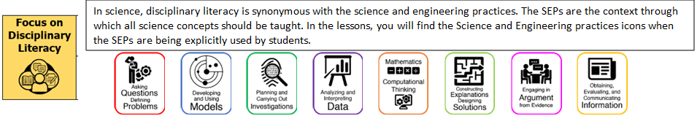

CONTENT STANDARDS
Below are the standards taught and assessed in this unit.
Learning Objectives (Students will be able to…)
B.12.A – analyze the interactions that occur among systems that perform the functions of regulation, nutrient absorption, reproduction, and defense from injury or illness in animals.
B.12.B – explain how the interactions that occur among systems that perform functions of transport, reproduction, and response in plants are facilitated by their structures
B.5.D – investigate homeostasis through cellular transport of molecules

UNDERSTANDINGS AND QUESTIONS
Important big ideas and processes for the unit.
Enduring Understandings
- Cells have membranes that separate the cell from the external environment
- Membranes consist of a phospholipid bilayer with numerous proteins embedded in and across the surfaces of the membrane
- Passive transport involves the movement of solutes across the membrane along the concentration gradient, without the additional use of energy
- Active transport involves the movement of solutes across the membrane against their concentration gradient with the use of additional energy
- Bulk transport of molecules across the membrane is accomplished through endocytosis and exocytosis
- Animals have organ systems that work together to transport nutrients and excrete waste
- The digestive system is needed to derive nutrients and basic building blocks (monomers) from food, which are required for cellular function and growth
- The circulatory system carries oxygen (hemoglobin in red blood cells carries O2) and nutrients to the cells all over the body and carries carbon dioxide and waste away from the cells.
- The respiratory system brings oxygen gas (O2) into the body and sends carbon dioxide (CO2) out of the body.
- The excretory system is needed to remove toxins and nitrogenous wastes from the body and to maintain water balance with the help of the circulatory system
- The nervous system collects and stores information from inside and outside the body. It controls the body’s actions and its responses to any changes. All five senses are part of the nervous system.
- The skeletal system Provides structure, supports, and protects internal organs.
- The muscular system provides structure, supports and moves the trunk and limbs, and moves substances throughout the body.
- The endocrine system produces chemical messengers called hormones that help maintain homeostasis and control growth and development.
- The integumentary system consists mainly of the skin. It serves as a protective barrier around your body preventing water loss and helping to control body temperature.
- The immune system is made of antibodies and white blood cells that protect your body from infection. HIV attacks a special type of white blood cell known as the Helper T cell.
- The reproductive system produces the gamete cells required for sexual reproduction. The male gamete cells are known as sperm and the female gamete cells are known as eggs.
- Xylem is the structure used by vascular plants transport water from the roots to the leaves and phloem is the structure used by vascular plants to transport food (sugars) from the leaves to the rest of the plant.
- Plants contain both male and female reproductive cells and organs and reproduce sexually through the fusion of gametes, either from themselves or another plant
- The petals are visually attractive to potential pollinators.
- Plants exhibit tropisms in that determine direction of growth towards or away from a stimulus, such as light, gravity, water, or touch
Key Questions
- What is homeostasis?
- What is the difference between passive and active transport?
- What is a concentration gradient?
- What are the roles of the cell membrane in transport?
- How do cells respond to changes in their environment to maintain homeostasis?
- How do cell transport processes contribute to maintaining overall cellular homeostasis?
- Which animal organ systems perform the function of regulation?
- How do animal organ systems work together to perform the function of regulation?
- Which animal organ systems perform the function of nutrient absorption?
- How do animal organ systems work together to perform the function of regulation?
- Which animal organ systems perform the function of reproduction?
- How do animal organ systems work together to perform the function of reproduction?
- Which animal organ systems perform the function of defense against illness/injury?
- How do animal organ systems work together to perform the function of defense against illness/injury?
- In animal organ systems, how does structure relate to function?
- Which plant organ systems perform the function of reproduction?
- How do plant organ systems work together to perform the function of reproduction?
- Which plant organ systems perform the function of transport?
- How do plant organ systems work together to perform the function of transport?
- Which plant organ systems perform the function of response to stimuli?
- How do plant organ systems work together to perform the function of response to stimuli?
- In plant organ systems, how does structure relate to function?

ROADMAP
Suggested daily guide for instruction in this unit.

Lesson #1: Passive and Active Transport |  | Date:
Objective  SWBAT: Utilize a model to investigate the similarities and differences between passive and active transport, making connections between the size of molecules, direction of movement, and the use of energy in the process.  Standards  B.5.C – investigate homeostasis through the cellular transport of molecules  Vocabulary  Diffusion  Passive transport  Active Transport  Semipermeable membrane  Science Practices  - Asking Questions  - Carrying Out Investigations  - Analyzing and Interpreting Data  - Using Mathematics and Computational Thinking  - Constructing Explanations  - Engaging in Argument from Evidence  Teacher note: Make corn syrup solutions day before 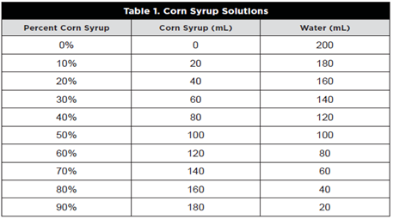 | Instructional Notes  Red Rover Send Particles Over Activity:  Students compare and contrast passive and active transport by playing a game to model this phenomenon. Movement through cell membranes is also modeled, as well as the structure and movement typical of the fluid mosaic model of the cell membrane. Concentration gradient, sizes, shapes and polarity of molecules determine the method of movement through cell membranes.  After this activity, students should be able to:  - Act as a different particle or part of the cell membrane to model active and passive transport.  - Explain how particles are transported from one side of the cell membrane to the other.  - Explain why engineers use models.  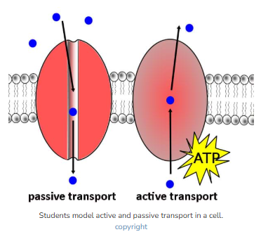 | Lesson Look Fors  Look for teachers to:  - Ensure that students are following the protocol appropriately.  - Walking around the room asking clarifying questions for why certain parts of the set up are crucial to the success of the experiment.  Look for students to:  - Carefully follow the activity protocol.  - Make an accurate claim based on evidence and reasoning.  Students Do and Know
   | - Create a graph of percent change in mass of baby carrots vs different concentration of solute.  - On the graph, find where the line crosses “0” and that will equal the concentration of syrup that is isotonic to the carrot cells.
   | - Semipermeable means that some things can enter/leave the cell while others cannot.
  - Diffusion is the movement of a substance from a region of higher concentration to a region of lower concentration. Since this requires no energy, this is called passive transport.
  - Active transport is movement of a substance against its concentration gradient (from a lower concentration to a higher concentration and DOES require energy.

Lesson #2: Diffusion Lab |  | Date:
Objective  SWBAT: model the response of cells undergoing osmosis when introduced to different solutions with different tonicities.  Standards  B.5.C – investigate homeostasis through the cellular transport of molecules  Vocabulary  Diffusion  Osmosis  Hypertonic  Hypotonic  Isotonic  Semipermeable membrane  Science Practices  - Asking Questions  - Carrying Out Investigations  - Analyzing and Interpreting Data  - Using Mathematics and Computational Thinking  - Constructing Explanations  - Engaging in Argument from Evidence  Teacher note: Make corn syrup solutions day before | Instructional Notes  This investigative lesson examines the process  of diffusion and osmosis through a selectively  permeable membrane. The lesson also explores  the change in the mass of a carrot piece through the  process of osmosis depending on the concentration of corn syrup.  Objectives:  - Explain how membranes are semipermeable and how that relates to plasma membrane structure.  - Differentiate between hypotonic, hypertonic, and isotonic conditions and how they are related to the process of osmosis.  - Collect data and determine the percentage of corn syrup that is isotonic to a raw carrot piece.  As you will have all of your class periods performing this experiment at the same time, it is advisable to use clear plastic cups that can be labeled with the class period and initials of the lab group.  Students might be able to provide the corn syrup and the carrots. We use baby carrots because they are somewhat uniform in size. | Lesson Look Fors  Look for teachers to:  - Ensure that students are following the protocol appropriately.  - Walking around the room asking clarifying questions for why certain parts of the set up are crucial to the success of the experiment.  Look for students to:  - Carefully follow the lab protocol.  - Effectively measure their baby carrots before and after sitting in the specific concentration of solute.  - Make an accurate graph of the data.  - Discuss with the lab partners what the data is showing.  - Make an accurate claim based on evidence and reasoning.  Students Do and Know
  - Create a graph of percent change in mass of baby carrots vs different concentration of solute.
  - On the graph, find where the line crosses “0” and that will equal the concentration of syrup that is isotonic to the carrot cells.
  - Semipermeable means that some things can enter/leave the cell while others cannot.
  - Hypertonic = more solute
  - Hypotonic = less solute
  - Isotonic = same concentration of solute

Lesson #3: Animal Organ System Card Sort (Review) |  | Date:
Objective  SWBAT: Describe the structures and functions associated with animal organ systems.  Standards  B.12.A – analyze the interactions that occur among systems that perform the functions of regulation, nutrient absorption, reproduction, and defense from injury or illness in animals.  Vocabulary  Circulatory System  Respiratory System  Digestive System  Nervous System  Endocrine System  Immune System  Reproductive System  Skeletal System  Muscular System  Integumentary System  Excretory System  Science Practices  - Developing and Using Models  - Engaging in Argument from Evidence | Instructional Notes  Students will participate in an animal organ system card sort. They were introduced to these organ systems in middle grades, so the focus of the learnings around these systems will be, as the TEK points to, how they interact with each other.  Activity #1: In this card sort, students will be given a set of cards where they will match each organ system with three characteristics: a picture of the system, the organs involved (the structure), and its function.  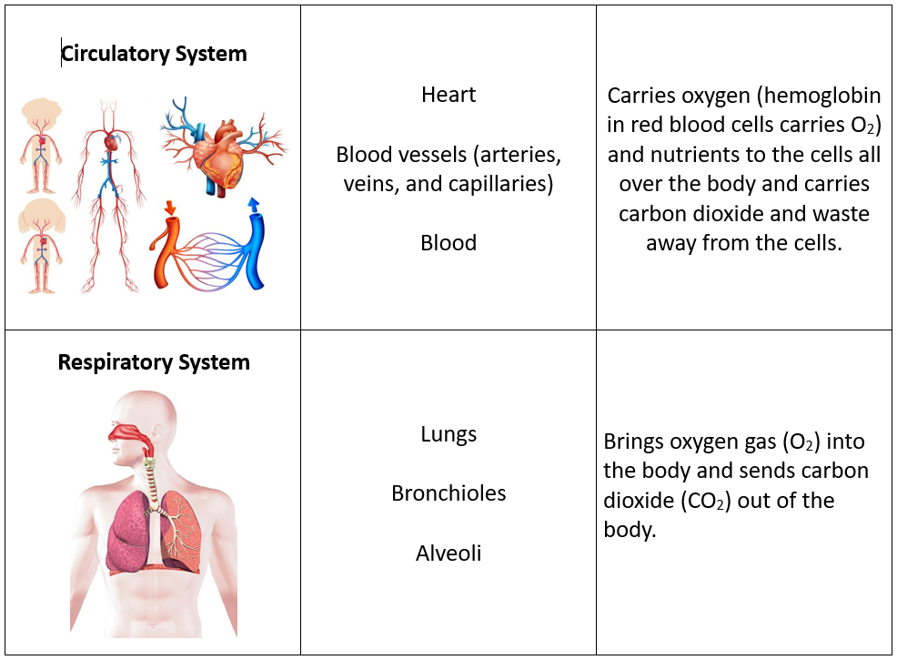  Activity #2: Students will then be put into groups (new groups if you chose to put them in groups for Activity #1) Now, groups will choose animal organ systems at random and work together to predict how those two systems “interact” with each other in order to carry out a function. |  | Lesson Look Fors  Look for teachers to:  - Allow students to productively struggle with the content, using accountable talk moves to facilitate the lesson.  - Teachers should be walking around the room ensuring that students are engaged in all activities correctly, consistently monitoring for incorrect biology.  Look for students to:  - Engage in the hands-on-minds-on modeling activity.  - Ask clarifying questions regarding what they are learning.  - Write in complete sentences.  - Make connections (interactions) in their own words.  Students Do and Know
  - Match each organ system with its respective organs/tissues.
  - Match each organ system with its respective functions.
  - Match each organ system with a picture/figure of that system.
  - Animals have organ systems that contain structures (organs/tissues) that aid in the facilitation of important processes.
  - Each organ system structure is designed in a way that serves a specific function.
  - The functions of the organ systems help animals to maintain homeostasis.

Lessons #4 and #5: Heart Rate Lab |  | Date:
Objective  SWBAT: Investigate the effect of exercise on heart rate and describe the organ systems involved.  Standards  B.12.A – analyze the interactions that occur among systems that perform the functions of regulation, nutrient absorption, reproduction, and defense from injury or illness in animals.  Vocabulary  Circulatory System  Respiratory System  Digestive System  Nervous System  Endocrine System  Immune System  Reproductive System  Skeletal System  Muscular System  Integumentary System  Excretory System  Science Practices  - Asking Questions  - Developing and Using Models  - Planning and Carrying out Investigations  - Analyzing and Interpreting Data  - Using Mathematics  - Constructing Explanations  - Engaging in Argument from Evidence | Instructional Notes  Day 1 – Prepping for Heart Rate Lab  Activity #1: Student read the intro to the lab and then participate in a group discussion of the question being investigated, why heart rates fluctuate, organ systems involved, and what variables are present in the investigation on Day 2.  Day 2: Heart Rate Lab  Activity #1: Students perform an interactive lab where they investigate the effect of exercise on heart rate. Students will read the experiment and follow the directions. Teachers will monitor students so they obtain accurate, usable data, in which to analyze if they will support or reject their hypothesis.  Ultimately, the students will exercise and measure change of heart rate between three different conditions (no exercise vs moderate exercise vs heavy exercise???). Students will either fill out a data table of group data, or you can put a table up on the board to collect class data. They will then take the data in the table and create a bar graph of the means for each group.  Activity #2: Students will then participate in an activity where they interact with the different animal organ systems that were involved in the experiment. Those organ systems are:  - Respiratory  - Circulatory  - Digestive  - Nervous  - Skeletal  - Muscular  - Bring in cellular respiration (resp, dig, and circ systems).  This activity is located at the end of the Heart Rate Lab. |  | Lesson Look Fors  Look for teachers to:  - Teachers should be walking around the room during the lab asking probing questions.  - Ensuring that students are correctly designing their table and graphs.  - Pushing students to draw their own conclusions based on the data, i.e., engaging in argument from evidence (claim, evidence, reasoning).  Look for students to:  - Engage in the lab and fill out the student document.  - Ask clarification questions regarding what they are learning.  Students Do and Know
  - Perform the exercise portion of the lab in order to collect appropriate data.
  - Create a table of the collected data.
  - Create a bar graph of class means.
  - Analyze the created graph and derive appropriate conclusions based on it.
  - Make connections between the different organ systems involved in the subject’s (student’s) body during the experiment.
  - Heart rate is part of the circulatory system.
  - The nervous system controls the nerves that keep the heart beating and tell it when to work faster (exercise).
  - The digestive system provides food needed for cellular respiration (energy needed for exercise).
  - The respiratory system provides oxygen needed for cellular respiration (energy needed for exercise).
Lesson #6: Organ System Stations |  | Date:
Objective  SWBAT: Describe the interrelatedness of animal organ systems, focusing on how they work together to accomplish a common goal.  Standards  B.12.A – analyze the interactions that occur among systems that perform the functions of regulation, nutrient absorption, reproduction, and defense from injury or illness in animals.  Vocabulary  Circulatory System  Respiratory System  Digestive System  Nervous System  Endocrine System  Immune System  Reproductive System  Skeletal System  Muscular System  Integumentary System  Excretory System  Science Practices  - Developing and Using Models  - Analyzing and Interpreting Data  - Engaging in Argument from Evidence  - Obtaining, Evaluating, and Communicating Information | Instructional Notes  Students will participate in an activity where they interact with different animal organ systems at different stations. At each station they will do the following:  - Identify the organs involved in a system.  - Discuss each system’s function.  - Describe a scenario where the systems at that station work together (interact) in order to facilitate a particular function.  - Investigate a disease and/or disorder where one of the systems at that station is defective and what that means for the rest of the organ systems in that individual.  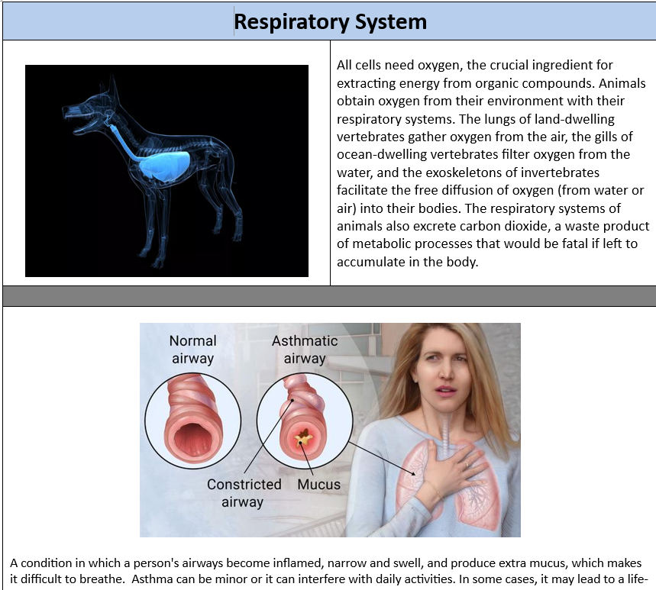 |  | Lesson Look Fors  Look for teachers to:  - Allow students to productively struggle with the content, using accountable talk moves to facilitate the lesson.  - Teachers should be walking around the room ensuring that students are engaged in all activities correctly, consistently monitoring for incorrect biology.  Look for students to:  - Engage in the hands-on-minds-on modeling activity.  - Ask clarifying questions regarding what they are learning.  - Write in complete sentences.  - Make connections (interactions) in their own words.  Students Do and Know
  - Identify organs involved in an organ system.
  - Relate structure with function.
  - Connect the structures/functions of one organ system with other systems.
  - Use claim-evidence-reasoning to defend/justify why a particular interpretation of interactions is correct.
  - Animals have organ systems that contain structures (organs/tissues) that aid in the facilitation of important processes.
  - Each organ system structure is designed in a way that serves a specific function.
  - The functions of the organ systems help animals to maintain homeostasis.

Lesson #7: Transpiration Lab |  | Date:
Objective  SWBAT: Investigate the process of transpiration by observing the movement of water through xylem tissues.  Standards  B.12.B – explain how the interactions that occur among systems that perform functions of transport, reproduction, and response in plants are facilitated by their structures  Vocabulary  Transpiration  Xylem  Root  Shoot  Leaves  Science Practices  - Asking Questions  - Developing and Using Models  - Planning and Carrying out Investigations  - Analyzing and Interpreting Data  - Using Mathematics  - Constructing Explanations | Instructional Notes  This lesson ties a very familiar demonstration of the uptake of food coloring by celery with the process of transpiration. Additionally, this lab provides students the opportunity to practice calculating rates.  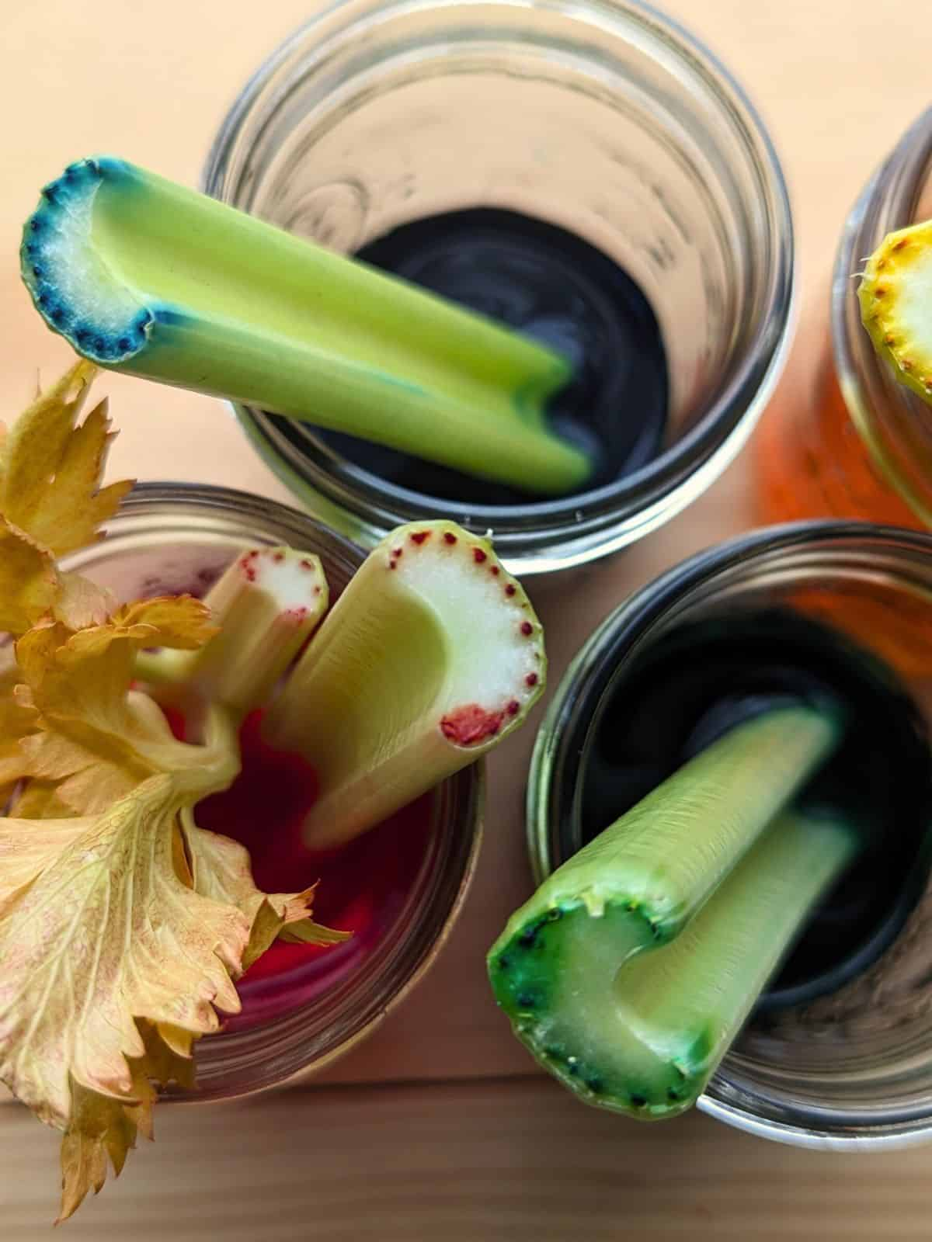  Students will:  - Investigate the process of transpiration by observing the movement of water through xylem tissues.  - Measure the rate of transpiration.  - Explore the plant structures that allow for transpiration to occur: stomata, guard cells, xylem, leaves, stems, and roots.  - Answer a series of conclusion questions related to what they experienced in the lab activity. |  | Lesson Look Fors  Look for teachers to:  - Allow students to productively struggle with the content, using accountable talk moves to facilitate the lesson.  - Teachers should be walking around the room ensuring that students are engaged in all activities correctly, consistently monitoring for incorrect biology.  Look for students to:  - Engage in the hands-on-minds-on modeling activity  - Ask clarifying questions regarding what they are learning  - Write in complete sentences  Students Do and Know
  - Follow an experimental procedure measuring the rate of transpiration in a celery stalk.
  - Calculate rate of water movement.
  - Develop a scientific question, develop a hypothesis, and design an experiment.
  - Transpiration is the process by which water moves through a plant and evaporates from its leaves, stems, and flowers.
  - Xylem is the plant structure that water and minerals flow through.
  - The root is a plant structure that is usually underground that absorbs water.
  - The primary function (most important job) of a stem is mechanical support and transport of water and food. Stems also connect the other organs of the plant.
  - Leaves are where photosynthesis occurs.

Lesson #8: Vascular Tissue in Plants |  | Date:
Objective  SWBAT: Use models to explain how plants carry out the functions of transport and reproduction.  Standards  B.12.B – explain how the interactions that occur among systems that perform functions of transport, reproduction, and response in plants are facilitated by their structures  Vocabulary  Xylem  Phloem  Root  Shoot  Leaf  Flower  Stomata  Guard Cells  Science Practices  - Analyzing and Interpreting Data  - Engaging in Argument from Evidence | Instructional Notes  Students will participate in an activity where they will be put into groups and each group will go to different stations involving how substances move through a plant. The stations will focus on the following:  - Roots  - Shoots  - Leaves  - Flowers  - Xylem  - Phloem  - Movement of water  - Movement of sugars (food)  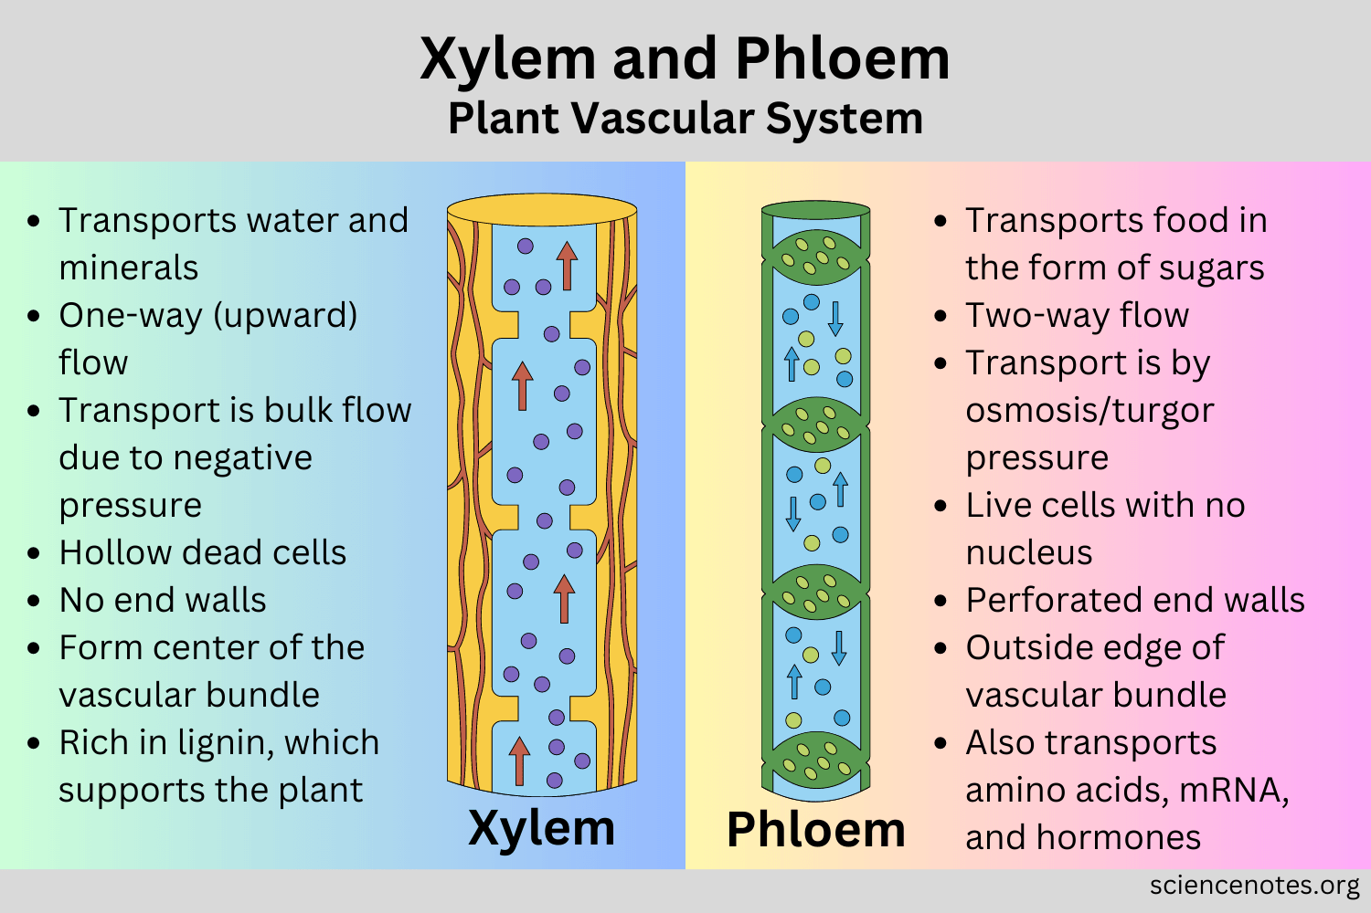 |  | Lesson Look Fors  Look for teachers to:  - Allow students to productively struggle with the content, using accountable talk moves to facilitate the lesson.  - Teachers should be walking around the room ensuring that students are engaged in all activities correctly, consistently monitoring for incorrect biology.  Look for students to:  - Engage in the hands-on-minds-on modeling activity  - Ask clarifying questions regarding what they are learning  - Write in complete sentences  Students Do and Know
  - Dissect a scenario and make meaning from its parts.
  - Create a concept map.
  - Xylem is the plant structure involved in water and mineral transport.
  - Phloem is the plant structure involved in water and food transport.
  - Food in a plant comes from the process of photosynthesis.
  - All cells in the plant need water, minerals, and food (products of photosynthesis).

Lesson #9: Flower Dissection |  | Date:
Objective  SWBAT: Discuss the parts of a flower and explain the process of fertilization.  Standards  B.12.B – explain how the interactions that occur among systems that perform functions of transport, reproduction, and response in plants are facilitated by their structures  Vocabulary  Stamen  Petal  Stigma  Style  Ovary  Anther  Filament  Science Practices  - Developing and Using Models  - Analyzing and Interpreting Data  - Engaging in Argument from Evidence | Instructional Notes  Students participate in a flower dissection, focusing on the structures that make up a flower and their respective functions, the steps of plant reproduction, the function of a fruit, and how pollen can get from one flower to another.  You may choose to dissect a live specimen if you have access to them, however, if you don’t then the Gizmo version is a wonderful way for students in dig into flowers, fruits, and plant reproduction.  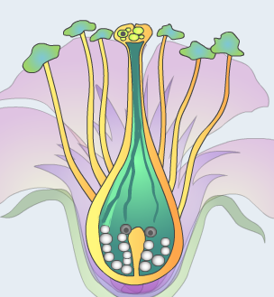  Lesson Overview  The Pollination: Flower to Fruit Gizmo allows students to examine the processes of self-pollination and cross pollination in flowering plants. Students discover the parts of the flower that are involved in reproduction as well as the role that each part plays in reproduction.  (Note: The related Flower Pollination Gizmo covers similar topics at a more basic level.)  The Student Exploration sheet contains two activities:  - Activity A – Students label a diagram and match flower parts to their functions.  - Activity B – Students explore the processes of pollination and fertilization. |  | Lesson Look Fors  Look for teachers to:  - Teachers should be walking around the room during the Gizmo activity asking probing questions.  - Allow students to productively struggle with the content, using accountable talk moves to facilitate the lesson.  Look for students to:  - Engage in the online lab and fill out the student document.  - Ask clarification questions regarding what they are learning.  - Writing in complete sentences  Students Do and Know
  - Identify flower parts with their functions.
  - Use a model to make sense of new biological vocabulary/concepts.
  - The carpal is the female part of the flower.
  - The carpel is made up of the stigma, style, and ovary.
  - The stamen is the male part of the flower.
  - The stamen is made up of the anther and the filament.
  - Pollen is transferred from the male part of the flower to the female part of the flower, which leads to fertilization (just like in animals).

Lesson #10: Plant Responses |  | Date:
Objective  SWBAT: Investigate the ways that plant tissues react to different environmental stimuli.  Standards  B.12.B – explain how the interactions that occur among systems that perform functions of transport, reproduction, and response in plants are facilitated by their structures  Vocabulary  Phototropism  Gravitropism (geotropism)  Thigmotropism  Hydrotropism  Science Practices  - Developing and Using Models  - Engaging in Argument from Evidence  - Obtaining, Evaluating, and Communicating Information | Instructional Notes  Activity #1: Students will be shown a PowerPoint of the 4 main plant tropisms and will jot down what they see and are told on a 4 square foldable.  Activity 2: Students will watch a video on plant tropisms.  Activity 3: Students will put all their learning together on a worksheet.  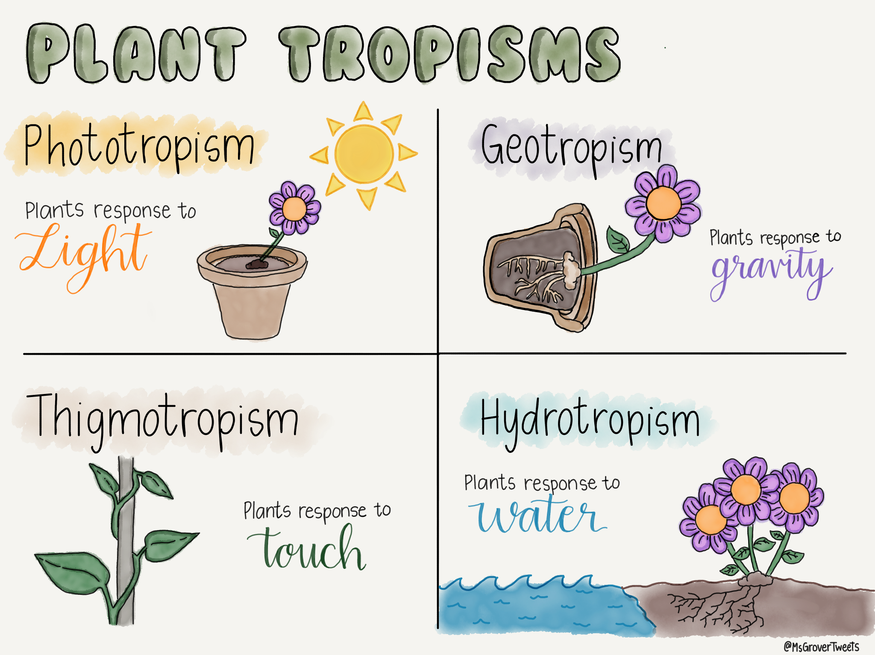  Activity #4: Students will create a concept map of the concepts that they learned about today. |  | Lesson Look Fors  Look for teachers to:  - Allow students to productively struggle with the content, using accountable talk moves to facilitate the lesson.  - Teachers should be walking around the room ensuring that students are engaged in all activities correctly, consistently monitoring for incorrect biology.  Look for students to:  - Engage in the hands-on-minds-on modeling activity  - Ask clarifying questions regarding what they are learning  - Write in complete sentences  Students Do and Know
  - Dissect a scenario and make meaning from its parts.
  - Create a concept map.
  - Gravitropism (geotropism) is a plant’s response to gravity, i.e., always growth “up.”
  - Thigmotropism is a plant’s response to touch.
  - Phototropism is a plant’s response to light.
  - Hydrotropism is a plant’s response to water.

Lesson #11: Making Connections |  | Date:
Objective  SWBAT: Explain how different concepts from Units 1-3 are related to concepts from Unit 4.  Standards  B.12.A – analyze the interactions that occur among systems that perform the functions of regulation, nutrient absorption, reproduction, and defense from injury or illness in animals.  Vocabulary  Circulatory System  Respiratory System  Digestive System  Nervous System  Endocrine System  Immune System  Reproductive System  Skeletal System  Muscular System  Integumentary System  Excretory System  Science Practices  - Developing and Using Models  - Constructing Explanations  - Engaging in Argument from Evidence | Instructional Notes  Today is all about students practicing making connections among concepts from not only Unit 4 but incorporating their learnings from Units 1-3. For instance, in order for any of the organ systems to have the energy (Unit 4) that they do, they need cellular respiration (Unit 3), which occurs in mitochondria (Unit 1). A cell in the heart (circulatory system, Unit 4) should have an abundance of mitochondria in order to power the heart to pump the blood around the body.  Activity #1: Students are given two sets of cards. The 1st set contains all of the organ systems studied in this unit. The 2nd set contains concepts/processes from the past three units. The students will choose three cards from the 1st set and one card from the 2nd set and then create a narrative of how all of the organ systems, concepts, and processes work together to accomplish a common goal.  Activity #2: Students should stay in their groups. Lead a whole group discussion on connections that each group made. Call on a group and ask them to list two concepts and the connection they made between the two. Then, lead a discussion using the following guided questions:  - “Does everyone agree on their connection? Why or why not?”  - “Can anyone make a different connection between those two concepts?”  - “Can anyone add a concept from one of the cards and describe how that concept connects to the two cards (concepts) they chose to share?”  - “Can anyone add a concept from one of the cards and describe how that concept connects to the three cards (concepts) just shared?” |  | Lesson Look Fors  Look for teachers to:  - Allow students to productively struggle with the content, using accountable talk moves to facilitate the lesson.  - Teachers should be walking around the room ensuring that students are engaged in all activities correctly, consistently monitoring for incorrect biology.  Look for students to:  - Engage in the hands-on-minds-on modeling activity.  - Ask clarifying questions regarding what they are learning.  - Write in complete sentences.  - Make connections (interactions) in their own words.  Students Do and Know
  - Use connections between and among biological concepts from multiple different units.
  - Use content knowledge to solve real-world scenarios.
  - Animals have organ systems that contain structures (organs/tissues) that aid in the facilitation of important processes.
  - Each organ system structure is designed in a way that serves a specific function.
  - The functions of the organ systems help animals to maintain homeostasis.

Day 12 | Review Day
Day 13 | Administer Unit Exam 4
UNPACKED STANDARDS
Focus standards for this unit.

Standards Clarification
Standards | Specificity | Notes/Explanations/Examples
B.12.A – analyze the interactions that occur among systems that perform the functions of regulation, nutrient absorption, reproduction, and defense from injury or illness in animals. | Standard breakdown:  - Analyze the interactions that occur among systems that perform the function of regulation in animals  - Analyze the interactions that occur among systems that perform the function of nutrient absorption in animals  - Analyze the interactions that occur among systems that perform the function of reproduction in animals  - Analyze the interactions that occur among systems that perform the function of defense from injury or illness in animals  Major concepts in this standard include:  - Functions and interactions in animal systems | In animals, no body system works in isolation. Each system contributes to the homeostasis and function of other systems. It is important that students identify body system parts and functions and provide explanations for the interactions among systems. Using precise academic vocabulary when describing interactions among animal systems is important in concept development.  When you teach this concept, remember to:  - Recognize the functions of individual animal systems: endocrine, excretory, integumentary, nervous, circulatory, respiratory, muscular, skeletal, reproductive, digestive, and immune.  - Provide opportunities for students to explore how systems interact to perform functions (e.g., regulation, nutrient absorption, reproduction, and defense against illness/injury).  - Have students evaluate a variety of visuals, models, and scenarios to analyze how animal systems are interrelated and interact. Help students recognize reflex responses and feedback mechanisms.  - Provide opportunities for students to create visuals, models, and written explanation of system interactions (e.g., noticing increased heart rate after running in place and analyzing its cause and effect).  Students may make the following mistakes:  - Confusing systems’ function and organs  - Not using components of systems to identify them (e.g., the brain for the nervous system, the heart for the circulatory system)  - Not recognizing that body systems interrelate and interact with one another
B.12.B – explain how the interactions that occur among systems that perform functions of transport, reproduction, and response in plants are facilitated by their structures | Standard breakdown:  - Explain how the interactions that occur among the systems that perform the functions [transport, reproduction, and response] in plants are facilitated by their structures  Major concepts in this standard include:  - Plant structure and function | Just as with animals, plants have specialized structures and systems that allow them to survive and maintain homeostasis. Leaves, stems, and roots interact to perform transport, reproduction, and response in plants. It is important that students not only identify plant parts and functions but also provide explanations for the interactions among plant systems. Using precise academic vocabulary when describing interactions between plant systems is important in concept development.  When you teach this concept, remember to:  - Review the structure and function of roots, stems, and leaves and explain how they relate to photosynthesis.  - Provide opportunities for students to investigate plant responses: geotropism, phototropism, and thigmotropism.  - Provide opportunities for students to investigate sexual and asexual reproduction in plants.  - Have students evaluate varied visuals, models, and scenarios to analyze how plant systems are interrelated and interact.  - Provide opportunities for students to create visuals, models, and written explanations of plant structures and plant system interactions.  Students may make the following mistakes:  - Thinking that only external factors cause responses  - Not recognizing that plant reproductive organs (male and female) are often housed in the same flower for self-fertilization

VERTCAL STANDARDS
This section details the progression of key student expectations/standards** in the courses before and after this course. This will help you understand what prior knowledge skills to build upon and guide you in knowing what skills you are preparing your students for in the subsequent course.

Biology Standard | Connections
B.12.A – analyze the interactions that occur among systems that perform the functions of regulation, nutrient absorption, reproduction, and defense from injury or illness in animals. | 7th Grade  - S.7.13.A – identify and model the main functions of the systems of the human organism, including the circulatory, respiratory, skeletal, muscular, digestive, urinary, reproductive, integumentary, nervous, immune, and endocrine systems;  8th Grade  - S.8.13.C – describe how variations of traits within a population lead to structural, behavioral, and physiological adaptations that influence the likelihood of survival and reproductive success of a species over generations.  AP Biology  - ENE-3.D – Explain how the behavioral and/or physiological response of an organism is related to changes in internal or external environment.
B.12.B – explain how the interactions that occur among systems that perform functions of transport, reproduction, and response in plants are facilitated by their structures. | 2nd Grade  - S.2.13.A – identify the roots, stems, leaves, flowers, fruits, and seeds of plants and compare how those structures help different plants meet their basic needs for survival;  4th Grade  - S.4.13.A – explore and explain how structures and functions of plants such as waxy leaves and deep roots enable them to survive in their environment; and  5th Grade  - S.5.13.A – analyze the structures and functions of different species to identify how organisms survive in the same environment; and  8th Grade  - S.8.13.C – describe how variations of traits within a population lead to structural, behavioral, and physiological adaptations that influence the likelihood of survival and reproductive success of a species over generations.  AP Biology  - ENE-3.D – Explain how the behavioral and/or physiological response of an organism is related to changes in internal or external environment.
VOCABULARY GLOSSARY
Domain-specific words and definitions for this unit.
Key Content Vocabulary
Circulatory System – animal organ system involved in delivering nutrients and oxygen to all cells of the body
Respiratory System – animal organ system involved in the exchange of gases and breathing
Digestive System – converts the foods we eat into their simplest forms, like glucose (sugars), amino acids (that make up protein) or fatty acids (that make up fats)
Nervous System – a complex network of nerve tissue that controls and coordinates an organism's actions and sensory information
Endocrine System – a network of glands in the body that produce hormones that help cells communicate with each other.
Immune System – a complex network of cells, tissues, and organs that protects the body from harmful substances, infections, and disease.
Reproductive System – a biological system that includes organs and other substances that work together to support sexual reproduction.
Skeletal System – made up of the bones that give structure to the human body
Muscular System – a group of muscles that work together to allow the body to move, maintain posture, and circulate blood.
Integumentary System – the largest organ of the body that forms a physical barrier between the external environment and the internal environment that it serves to protect and maintain
Excretory System – a biological system that removes waste products from the body to maintain homeostasis
Homeostasis – the tendency toward a relatively stable equilibrium between interdependent elements, especially as maintained by physiological processes.
Carpel – ovule-bearing female reproductive organ of flowering plant
Stigma – It is found in the center of a flower and helps to collect pollen. The stigma is on top of the style and is the apex of the reproductive system. It is waxy or sticky to collect the dry pollen which is blown by the wind or transferred by insects.
Style – It connects the ovule-bearing ovary at the bottom to the pollen-receptive stigma at the top.
Ovary – enlarged basal portion of the pistil (carpel), the female organ of a flower
Ovules – eggs
Anther – male component of a flower that produces and hold onto the pollen
Filament – flower structure that hold the anther in the air
Photosynthesis – process where plants (and algae) produce sugars from light energy, carbon dioxide, and water
Root – important underground part of all vascular plants. This part of the plant is mainly responsible for anchoring it down into the ground and absorbing the essential mineral elements, nutrients, and water from the soil. It is also used to store food.
Shoot – the part of a plant that grows above ground, and is made up of the stems, leaves, buds, and flowers
Leaves – any usually flattened green outgrowth from the stem of a vascular plant. As the primary sites of photosynthesis, leaves manufacture food for plants, which in turn ultimately nourish and sustain all land animals. Botanically, leaves are an integral part of the stem system
Stomata – opening on leaves that allow gases to enter and exit
Guard cells – cells that allow the opening and closing of the stomata
Phototropism – plant response to light
Gravitropism – plant response to gravity
Thigmotropism – plant response to touch
Hydrotropism – plant response to water

